Objectives
When you have completed this lab activity, you should be able to:
1. explain the essential difference between chemical sediment and detrital sediment.
2. describe how and why detrital sediment is deposited.
3. describe how and why chemical sediment are deposited.
4. explain how the speed of flowing water affects (a) the sizes of detrital sediment particles that the water can carry and (2) the sizes of detrital sediment particles that the water deposits.
5. explain why detrital sediment is often layered by particle size.
6. distinguish two very different mechanisms by which crystals can grow in a fluid.
7. explain how sediment is transported from far inland to the sea.
8. describe how running water can transform a featureless terrain into a complex landscape of ridges and valleys.
9. distinguish between erosion and deposition.
10. identify the following features of a river: tributaries, trunk stream, delta, distributaries
Important Definitions
Dissolved: a substance is dissolved in a fluid (liquid or gas) when its component ions, atoms or molecules have become separated and individually surrounded by molecules of the fluid.
Sediment: solid material that has settled to the ground or to the bottom of a body of water.
Chemical Sediment: Sediment that was once dissolved in water.
Detrital Sediment: Sediment that was never dissolved in water.

Activity #1: Chemical vs. Detrital Sediment
Materials: 1 clear plastic cup containing fine-grained halite (table salt)
1 clear plastic cup containing powdered clay
water
2 stirring rods
Prediction: Which do you think will dissolve in water: the salt, the clay, neither or both? Explain the reasoning behind your answer.

Activity: • Add water to each cup until it is approximately 2/3 full.
• Thoroughly stir the contents of each cup for at least a minute.
• Observe each cup right after you have finished stirring.
Questions:
1. Draw diagrams of the two cups immediately after you have finished stirring.

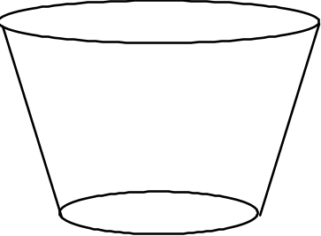

Water + Salt | Water + Clay

2. Which substance dissolved in the water: the clay, the salt, neither or both? Use your observations of the two cups to justify your answer.

More Activity: • Let the two cups rest undisturbed on the lab table for an hour or so.

More Questions:
3. Draw diagrams of the two cups after they have rested on the lab table for an hour or so.

Water + Salt | Water + Clay

4. Explain why the distribution of sediment in the two cups is so different.

5. Clay is a detrital / chemical sediment (circle the correct answer).
Salt is a detrital / chemical sediment (circle the correct answer).
Activity #2: Causing the Precipitation of Chemical Sediment from a Solution
Materials: salt water (solution of sodium chloride in water)
spoon
one glass Petri dish
10x magnification hand lenses
metal stand with a heat lamp on it, pointing down

Activity
1. Place a few spoonfuls of salt water into the Petri dish. Look at the solution with a hand lens. Draw a diagram of the Petri dish in the space provided below (Question 1).
2. Place the Petri dish under the heat lamp and let the water gradually evaporate. Go on and do Activities 3 and 4. After 10-15 minutes, examine the Petri dish and answer the questions below.

Questions:
1. Draw diagrams of the Petri dish, before and after the water evaporated.



Before Water Evaporated | After Water Evaporated

2. What caused the crystals to form in the Petri dish?

3. How is the process that formed these crystals fundamentally different from the process that formed the crystals of salol in the test tubes (you did this a couple of weeks ago)?

Activity #3: Studying the Deposition of Detrital Sediment
Materials: Mason jar with water and detrital sediment in it.
Dry detrital sediment: Mixture of gray pea gravel, fine white sand and a small amount of dark silt (the black "dirt" in central and western Chico is ideal).

Activity:
1. Shake the jar vigorously; the water picks up the detrital sediment, just as a flowing stream does.
2. Stop shaking the jar and watch what happens to the detrital sediment as the water slows down and comes to rest.
Questions:
1. What causes the detrital sediment to become suspended in the water?

2. What causes the detrital sediment to settle to the bottom of the jar?

3. Do the smallest grains land on the top or on the bottom of the layer? Why?

4. What is the important factor in determining which grains land on the bottom of the layer, their weight or their density? Why?
(Hint: what happens to the density of a large boulder when it's broken into small pieces?)

5. What natural river or ocean processes could result in the deposition of detrital sediment?

6. After most of the detrital sediment has settled, draw a diagram of the sediment in the jar, noting especially any variations in the size and/or color of the sedimentary particles.

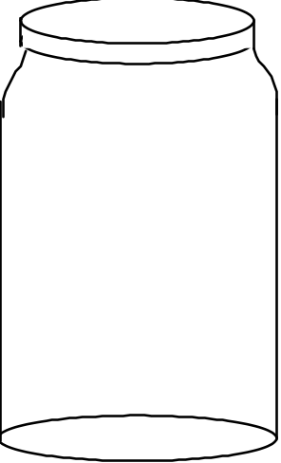

More Activity: Open the top of the jar and add another 1/4 cup or so of sediment; watch it settle. Repeat several times. Note the layering; such layering is always present in sedimentary rock.

Questions:
7. Draw a diagram of the multiple layers of detrital sediment in the jar, noting especially any variations in size and/or color of the sediment.

8. Describe a natural scenario that could result in the deposition of distinct layers of detrital sediment.

Activity #4: Watching Running Water Modify a Landscape
Materials: 2 large plastic trays, each with a small hole in one end
small rubber stopper
moistened sediment (diatomaceous earth--the kind used for swimming pool filtration-- mixed with a small amount of fine sand)
large (1 or 2 liter) plastic beaker
spray bottle full of water
sponge

Activity:
1. Initial set-up
a. The sediment in your tray should be pre-moistened. If it is not, ask your instructor to do it. If it contains excess water, pour the water into the bucket provided for that purpose at the front of the room.
b. Plug the hole in the tray with the rubber stopper. Mix the moistened sediment well, using your hands (Kids love this part.). You will have to scrape the sediment off of the bottom using lots of elbow grease. Mix the sediment well until the sand (tan) is evenly distributed in the diatomaceous earth (white). If necessary, add some water until the sediment has the consistency of a mud pie.
c. Turn the empty tray upside down. Rest the tray containing the moistened sediment on the edge of the empty tray, with the plugged hole on the uphill side of the tray.
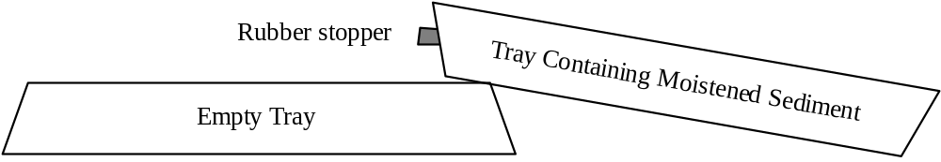
d. Push the sediment to the side of the tray opposite the hole and pat it down; it will probably become very soupy when you do this. The sediment should cover about half of the bottom of the tray.
e. Use the sponge to clean as much sediment as possible from the exposed bottom of the tray.

Comments: This is a small-scale model of a landscape. An inch on the model represents about a mile on a real landscape. A grain of sand represents a boulder. Regarding evolution of the landscape, one minute of the experiment is equivalent to about 1000 years in real life.
2. Running the Experiment:
a. When the sediment feels slightly firm when you press down on it, gently and slowly (so as not to disturb the sediment), lower the tray of sediment until it is flat on the table.
b. Fill the plastic beaker with water and SLOWLY pour water into the sediment-free side of the tray just until there are no more dry spots on the bottom of the tray. This water represents the ocean; the sediment represents the land.
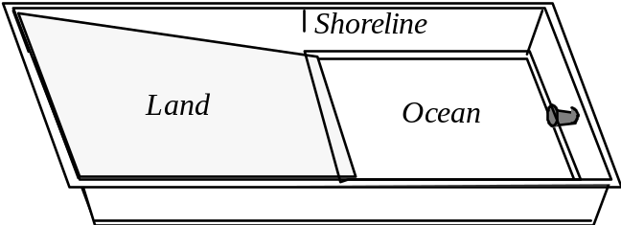
c. Watch as water drains off of the “land.” It will form several streams. At first, nothing may appear to be happening. Be patient and keep watching. Try to be the first in your group to see a stream appear.
d. Continue watching as the running water carves a landscape by eroding, transporting and depositing sediment. Be sure to watch what happens in the ocean as well as what happens on land.

Observation Questions:
1. Where, in the model, is erosion occurring?

2. Where in the model is deposition occurring?

3. Explain the essential difference between erosion and deposition.

4. What is the predominant sediment that is eroded from the land, transported by the streams, and deposited into the ocean? The diatomaceous earth (white) or the sand (tan)? Why?

5. Is sediment deposited as one even layer in the ocean, or is more sediment deposited near the shoreline? Explain why this occurs.

More Activity: Continue Running the Experiment:
a. Gently spray a fine mist of water over the land (a few “squirts” should be enough)--you have just made it rain!
b. Watch the water run off the land. Notice how efficiently the streams channel the water from the land to the ocean.
c. Repeat several times, causing the landscape to continue to evolve.

More Questions
6. Does the upper surface of the sediment end up with coarser or finer sediment than it had when it started? Why does this happen? Draw diagrams to illustrate your answer.

7. If you drive south on Highway 99 from Chico, you see rolling hills covered with grass and thousands upon thousands of large boulders. The bedrock underneath these boulders is a sedimentary rock composed of mud- to boulder-size sediment. Use your answer to questions #1 and #3 above to formulate a hypothesis as to why the hills south of Chico are covered with boulders. (Hint: contrary to popular myth, these boulders were not thrown out of the Mt. Lassen volcano).

8. Draw a diagram of the final state of your experiment. Label the following features on your diagram: tributaries, trunk streams,5 meanders, deltas and distributaries.7

Remember to go back and finish Activities #1 and #2!

Objectives
When you have completed this lab you should be able to:
1. Identify five types of sedimentary rocks: conglomerate, sandstone, mudstone, limestone, and rock salt.
2. Identify some minerals in sedimentary rocks, especially quartz, clay, calcite, halite, and iron oxides.
3. Examine a sample of any of these rock types and tell the “story” of how it formed.
4. Identify three basic types of metamorphic rocks: quartzite, marble and schist.
5. Describe how foliation forms in metamorphic rocks.

Background Information About the Classification of Sedimentary Rocks
Sedimentary rocks are divided into two main categories: detrital (made of “bits and pieces of decomposed rock” that were never dissolved in water) and chemical (made of minerals that were once dissolved in water). Detrital sedimentary rocks are, in turn, classified by the size of the sediment it is made of—since sediment size is an indicator of the speed of the current that deposited the sediment. Chemical sedimentary rocks, on the other hand, are classified by the minerals they are made up of—since the mineral composition is an indicator of the chemical properties of the water from which the chemical sediment was deposited. The table on the next page summarizes the classification of sedimentary rocks.

Background Information About Depositional Environments
Sedimentary rocks contain a variety of clues that can help you figure out how and in what type of environment they were deposited. Here are some examples:
1) Sorting of Detrital Sediment: Sediment that was deposited on the bottom of a body of water is typically sorted by size (all the particles in each layer--which may be very thin--are about the same size) but sediment that was deposited as a mud flow is typically not sorted by size at all--boulders, pebbles, sand and clay particles are all jumbled together.

2) If detrital sediment is well-sorted by size, the sizes of the sediment particles provide clues as to how fast the water was flowing. The larger the particle size, the faster the water must have been flowing.

3) As detrital sediment is transported by flowing water, the sedimentary particles bang against each other and wear each other smooth, rounding any sharp edges. Thus the more rounded the grains of detrital sediment; the farther the sediment was transported.
Classification of Sedimentary Rocks

Detrital Sedimentary Rocks | Chemical Sedimentary Rocks
Made of detrital sediment--“Bits and pieces of decomposed rock” that were never dissolved in water | Made of chemical sediment--sediment that was once dissolved in water
Classified by size of sediment | Classified by mineralogy of sediment*
Classification  Sediment Size Rock Name  Gravel, rounded Conglomerate  Gravel, angular Breccia  Sand Sandstone  Silt and Clay Mudstone | Classification  Sediment Mineralogy Rock Name  Halite Rock Salt  Calcite** Limestone

*Halite and calcite dissolve much more readily in water than do most other minerals. Therefore, halite and calcite are common chemical sediments. For the same reason, detrital sediment is rarely composed of halite or calcite (one exception: gravel-sized pieces of limestone are common in desert environments where chemical weathering occurs very slowly).

**Most natural calcite is “biochemical” because it was initially removed from the water by water-dwelling organisms which used the calcite to make their shells or skeletons. When these organisms die, under the right conditions, these “hard parts” of their bodies accumulate as a layer of sediment.

Activity #1: Identification of Sedimentary Rocks
Materials: Sedimentary rocks labeled C, D, E, F, G, H, I, J, K, L, M, N
One hand lens per person
Mineral identification equipment (piece of glass, streak plate, acid bottle, penny)
8 pieces of 8.5" x 11" scrap paper
Activity:
1. Label the pieces of scrap paper and arrange them as shown here:  2. Using the classification table above, sort the sedimentary rocks by type and place them on the appropriate pieces of paper.
  Detrital |  |  | Chemical
  Conglomerate | Breccia |  | Limestone
  Sandstone |  |  | Rock Salt
  Mudstone
Question:
1. Write the name of each rock next to its letter:
C. I.
D. J.
E. K.
F. L.
G. M.
H. N.

Activity #2: Interpretation of Sedimentary Environment
Materials: Sedimentary rocks labeled C, D, E, F, G, H, I, J, K, L, M, N
One hand lens per person
Mineral identification equipment (piece of glass, streak plate, acid bottle, penny)
Activity: Read the “Background Information About Depositional Environments” at the beginning of this lab. Then examine the rocks as directed below and answer the questions about them.
Questions:
1. Closely examine rocks G and I. One of these rocks was deposited on the bottom of a body of flowing water. The other was deposited as a mud flow. Which is which? Explain the reasoning behind your answer.

2. Closely examine rocks H and F; be sure to look at them with a hand lens. Both rocks were deposited on the bottom of a body of flowing water. For which rock was the water flowing faster? Explain the reasoning behind your answer.

Activity #3: Identifying the Metamorphic Rocks
Background Information: There are only three basic types of metamorphic rocks that we will be studying in this class. These rocks are described in the table below.

Metamorphic Rock Identification Table
Name | Mineral Composition | Description | Parent Rock  (protolith)
Marble | Calcite | Made of light-colored crystals of calcite that are visible to the naked eye. Rock sparkles because the cleavage faces of the crystals reflect light. Can be foliated but the foliation is typically less obvious than it is in schist. | Limestone
Quartzite | Quartz | Looks grainy but has a slight waxy sheen. On some samples, the original sand grains are still visible. Can be foliated but the foliation is typically less obvious than it is in schist. | Quartz-rich Sandstone
Schist | Variable. Common minerals include chlorite, mica and garnet. Most common variety is composed primarily of mica and quartz. Flat sides of crystals are aligned. | Foliated (i.e. flat minerals oriented roughly the same way). Breaks into (sometimes bumpy) sheets parallel to foliation. | Usually mudstone, but can also derive from other rock types.
A. Materials: Metamorphic rocks: AA , BB, CC, DD, EE, FF, GG
B. Activity: Identify each rock; note the incredible variety of rocks that have the same name.

AA
BB
CC
DD
EE
FF
GG
Activity #4: Growth of Minerals During Metamorphism
A. Materials: Videotape Rocks that Originate Underground

B. Activity: Watch the segment on metamorphic rocks, especially the effect of heating on the steel wafer.

C. Questions:
1. What is happening to the molecules in the steel that allows the crystals to grow?

2. How are the changes in the steel similar to the changes in the metamorphic rocks?

Activity #5: Formation of Foliation During Metamorphism
A. Materials: Plastalena clay with glitter mixed in it; one piece per person.
Piece of schist (yes, really!)--Rock GG
You will use the clay-glitter mixture to model the behavior of solid rock as it forms a rock like GG. The glitter represents mica and the clay represents quartz. The clay is much easier to mold than real quartz is; so you can accomplish in a few minutes what it takes Mother Nature millions of years to do.

B. Activity: Work the clay, in any way you wish, to make the glitter particles line up with each other so that the clay/glitter mixture looks like rock GG.

C. Questions:
1. What natural processes could accomplish the same result in rocks?

2. Which of the metamorphic rocks (AA, BB, CC, DD, EE, FF, and GG) are foliated?

Dates/Times: See your syllabus for dates. Note that lab will run an extra hour on field trip day; please plan carefully for this. Specifically,
• 9–11 labs meet an hour early, at 8 a.m.
•12–2 labs meet an hour early, at 11 a.m.
•11–1 labs go an hour late, until 2 p.m.
• 2-4 labs go an hour late, until 5 p.m.
Place: We will meet at the bus-loading zone on the east side of Holt Hall, across from the Bidwell Mansion (the same place here BIOL 342 meets for field trips). We will be going to Bear Hole in Upper Bidwell Park (see map on next page).
What to Bring: Be prepared for rough trails and a short but steep uphill hike. Bring…
• This lab and a clipboard or other hard surface to write on.
• pencil
• water (the MOST important thing--you will be miserable without it)
• hat (light colors are best) to protect your head from the sun and to keep you cool; a baseball cap is fine but a visor will not do. VERY IMPORTANT! If you do not wear a hat, you will be EXTREMELY hot and miserable. There is no shade out there--don't forget your hat!
• sturdy shoes (hiking boots and athletic shoes are best; sandals, flats, & high heels will NOT do)
• sunglasses
• camera (optional)

Objectives
The primary purpose of this field trip is to see geology at its most real--in context instead of isolated in the lab--all around you instead of just in front of you. Secondary objectives include…
• to learn a little about topographic maps.
• to see several major rock formations of the Chico area.
• to identify rocks in outcrop.
• to understand where Chico's municipal water supply comes from.
• to use geologic reasoning to figure out how this area has changed over time.
• to get outside and have a good time.
Map to Bear Hole in Upper Bidwell Park
Driving Directions:
• From campus, take 2nd St. east; follow it across Big Chico Creek as it turns into Vallambrosa.
• Continue to follow Vallambrosa until it ends at Manzanita Ave.
• Turn left onto Manzanita Ave.
• Pass the Hooker Oak recreation area on your right; cross a bridge (over the Lindo Channel).
• Turn right onto Wildwood Ave., the entrance to Upper Bidwell Park (marked by a large wood sign).
• Follow the park road past the golf course and through a gate.
• Continue 2 miles past the end of the pavement; turn right into the Bear Hole parking lot.

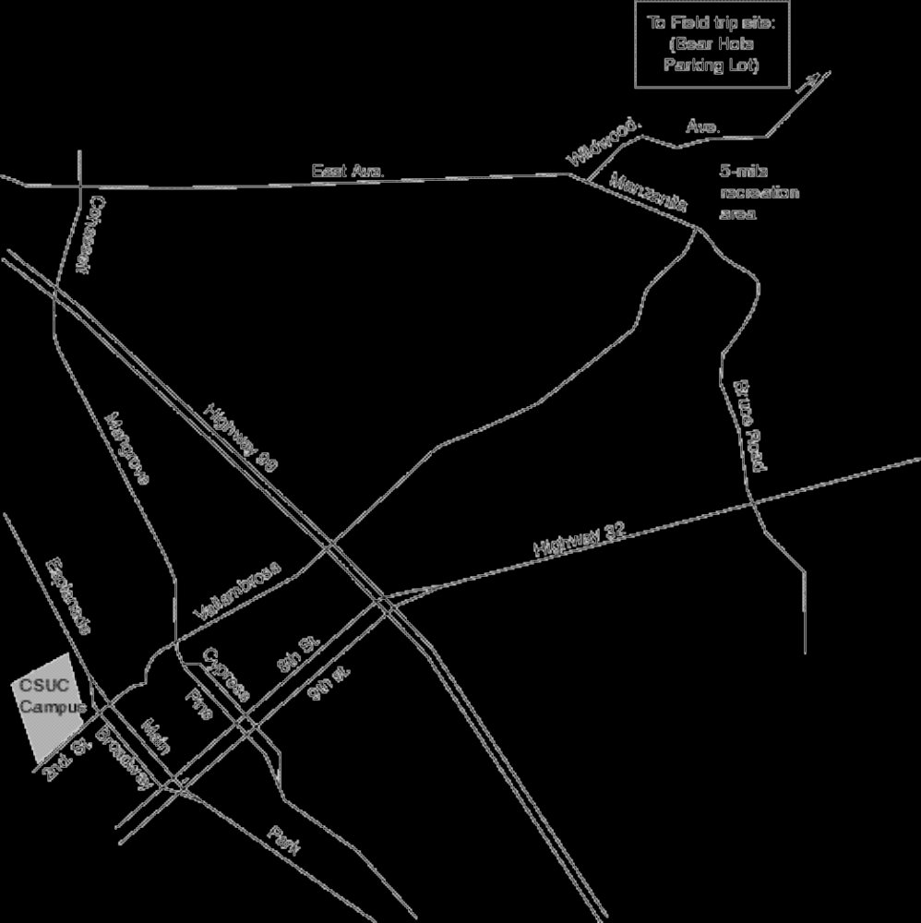
Stop #1 (Bear Hole Parking Lot): Introduction to the Topographic Map
Examine your topographic map of the Bear Hole area (on the back page of this lab). The gray lines that wiggle all over the map are topographic contour lines. Each topographic contour line connects points of a certain elevation above sea level. If you were to walk along one of these lines, you would never go up hill or down hill. To help you keep track of all these lines, every fifth contour line is extra thick. Only the extra thick lines are labeled but you can determine the exact elevation of each line if you know the contour interval, the vertical drop (or climb) between two contour lines.

1. Find the Bear Hole parking lot on the topographic map; plot your location (label it Stop #1) on the map.
2. Determine your elevation .

3. Wherever topographic contour lines are close together, the slope of the land is steep / gentle (circle the correct answer).

4. Wherever topographic contour lines are far apart, the slope of the land is steep / gentle (circle the correct answer).

5. Look across the creek and up to the cliff on the top of the ridge. Find that cliff on the topographic map. Circle the spot on the map that represents the cliff. How do you know, from the map, that this is a cliff?

6. Notice that each topographic contour line forms a “V” where it crosses Big Chico Creek.

a. The point of each “V” points upstream / downstream (circle the correct answer).

b. Could you start from here and cross the creek without ever going uphill or downhill? If not, why not? If so, what route would you take? Draw a diagram to illustrate your answer.

Walk down to the creek and follow the trail (an old flume) a little ways upstream.

Stop #2 (Bear Hole itself): The smooth black rock
7. Plot the location of Stop #2 on the topographic map.
8. This rock type is called the Lovejoy Formation and it is about 16 million years old. What kind of rock is this?

9. This rock is igneous / sedimentary / metamorphic. (Circle the correct answer.)

10. How did this rock form?

11. Note the vertical cracks in the rock (see diagram). They formed at the same time that the rock formed; in fact, they are characteristic of this type of rock. What made these cracks form?

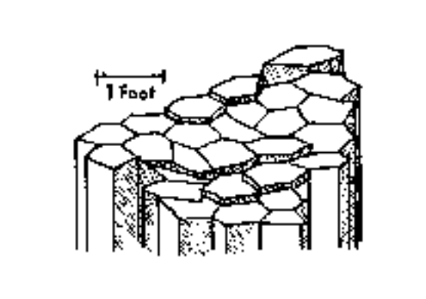
(Source of Diagram: Guyton and DeCourten, 1978, p. 6)

Return to the parking lot. Walk to the far west side of the parking lot and follow a trail steeply downhill. You will shortly encounter an unmarked T-intersection with the Yahi trail. Turn right onto the Yahi trail (toward Chico). You will shortly will enter a heavily shaded side canyon. Just after crossing the small creek on the bottom of the side canyon, you will encounter an oucrop wall on your right..

Stop #3: The Nomlaki Tuff, A Special Layer within the Tuscan Formation

12. Plot the location of Stop #3 on the topographic map.

13. The rocks cropping out here are part of the Nomlaki Tuff, a layer within the Tuscan Formation. This rock layer crumbles easily. Pick up some pieces of this crumbled rock and examine them. Describe its characteristics.

14. How did this layer form? What type of geologic event was responsible for forming this layer?

Continue along the Yahi trail until you can clearly see Big Chico Creek nearby on the left. Climb down the steep bank to the creek. Examine the outcrops exposed here.

Stop #4: A Different Type of Rock within the Tuscan Formation

15. Plot the location of Stop #4 on the topographic map.

16. The rocks you see here form the main type of layer in the Tuscan Formation. Describe this outcrop by answering the following questions:
a. What size(s) of sedimentary “particles” make up this rock (boulders, gravel, sand, mud)?

b. What kind of rock is this?

c. The sedimentary particles in these rocks are well-sorted by size / poorly sorted by size. (Circle the correct answer.)
Note: To be considered well-sorted, all of the particles in any one layer must be about the same size; there can be major sediment size differences between layers.
d. The edges of the sedimentary particles in this rock are
somewhat angular / very worn and smoothly rounded. (Circle the correct answer.)
e. Some of the sedimentary particles are pieces of rock. What kinds of rocks can you identify (We're looking for names of rocks here, not minerals)?

f. Which of these rock types is the most common?
g. Are any of the sedimentary particles in this rock actually pieces of the smooth black rock you saw at the last stop? Explain.
Note: Not all rocks of the same type are alike. For example, some sandstones are made of 100% quartz grains and some sandstones have no quartz grains at all. Just because two rocks are of the same type does not mean that they are identical.

17. Based on your answers to #16 above, make some interpretations of the way these sediments were deposited and in what kind of environment they were deposited. Do this by answering the following questions:
a. Was this sediment deposited on the bottom of a body of water or was it deposited as a debris flow ? What evidence led you to this conclusion?

b. If you could go back in time and stand on this spot right after this sediment was deposited, what kind of landform (canyon, mountain range, volcano, ocean, lake, or river) would you see in the distance if you looked toward the northeast? Explain the reasoning behind your answer. Draw a diagram to illustrate your answer.

c. What kind of major geologic event(s) may have triggered the transportation and deposition of this sediment? Explain.

Follow the creek upstream until you reach the contact between the Lovejoy Formation and the Tuscan Formation.

Stop #5 (Located Between Stops 2 and 4):
The Contact Between the Tuscan Formation and the Lovejoy Formation

18. Plot the location of Stop #5 on the topographic map.

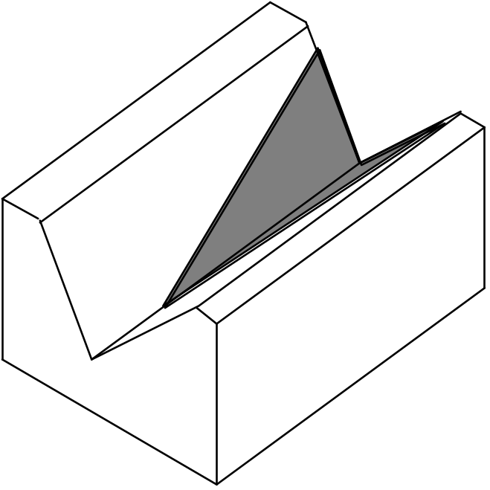
19. Which rock unit is older, the Tuscan Formation or the Lovejoy Formation? How do you know? To illustrate your answer, label each formation and draw in the layers on the side and front of the block diagram below.

Follow a trail back uphill. Briefly stop just above where this trail crosses the Yahi trail, where itl begins to level out and turn to the right (and where the trees meet the grass lands). There's a small outcrop on the right.

20. You’ve seen this rock unit at one of the previous stops. What is it? _______________________

Return to the parking lot and walk along the driveway back to the main park road. Cross the road and walk uphill, through the grass and weeds, to a large prominent gray rock outcrop (visible from the road--when you get to it, it will be about twice as tall as you are).

Stop #6 (After a long hard uphill hike): A Cliff Formed by a Fourth Type of Rock

21. Plot the location of Stop #6 on the topographic map.

22. These rocks make up another common layer within the Tuscan Formation. In fact, the Tuscan Formation is primarily made of alternating layers of the type of rock that you saw at Stop #4 and these types of rocks. However, the rocks at this location have a very different origin than the rocks at Stop #4.
a. What size(s) of sedimentary “particles” make up these rock layers (boulders, gravel, sand, mud)?

b. The rock layers exposed here are just two basic sedimentary rock types. What are these rock types?

c. The sedimentary particles in these rocks are well-sorted by size / poorly sorted by size. (Circle the correct answer.)
Note: To be considered well-sorted, all of the particles within any one layer must be about the same size; there can be major sediment size differences between layers.

d. The edges of the sedimentary particles in this rock are
somewhat angular / very worn and smoothly rounded. (Circle the correct answer.)
e. Some of the sedimentary particles are pieces of rock. What kinds of rocks can you identify (We're looking for names of rocks here, not minerals)?

f. Which of these rock types is the most common?

23. Based on your answers to #22 above, make some interpretations of the way these sediments were deposited and in what kind of environment they were deposited. Do this by answering the following questions:
a. “These layers of sediment were deposited on the bottom of a body of water.”
Describe specific evidence for this statement and how this evidence can be used to show that the statement is true.

b. In what kind of body of water were these sediments deposited (circle the correct answer)?
ocean / lake / river in a narrow valley / river in a wide flat valley
Explain the evidence and reasoning behind your answer.

c. If you could go back in time to when these sediments were being deposited, you would not be able to see the rocks at Stops 1 through 5. Explain why you would not be able to see them. Draw a diagram to illustrate your answer.

24. The rock layer we are standing next to is an excellent aquifer - a layer that can hold a lot of ground water and that allows ground water to flow through it easily. Chico's drinking water is pumped out of wells that tap layers just like this one, hundreds of feet below the city of Chico (see diagram).
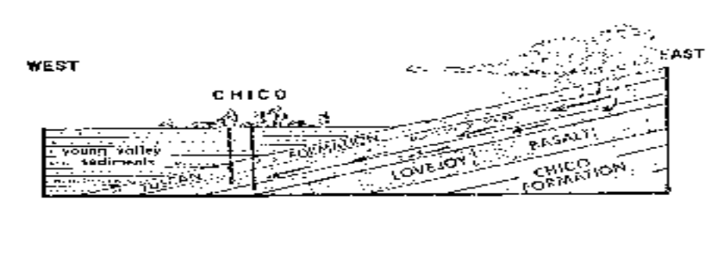
(Source of Diagram: Guyton and DeCourten, 1978, p. 12)
a. The source of our drinking water is rain falling here, in the hills east of town where these layers are exposed at the surface. How does the water get from here to the wells?

b. Why does this water flow westward, toward Chico, instead of flowing straight down? To illustrate your answer, add to the diagram on the previous page.
(Hint: Do you think that the Lovejoy Formation is a good aquifer?)

25. A few years ago, there was a big controversy about housing development in “Bidwell Ranch,” the land immediately north of Upper Bidwell Park. What do you suppose will happen to the quality and quantity of Chico's water supply if major development is allowed at Bidwell Ranch?

Return to the Bear Hole Parking Lot (Stop #1)

Second Visit to Stop #1: The Bear Hole Parking Lot

26. Look across the creek and notice several areas of bright-green vegetation. The plants in these spots are fresh and green, even in late summer when it hasn't rained for months and all of the other vegetation in the area is brown. Obviously, there must be some source of water in these spots that lasts all year.
a. Where is this water coming from?

b. Why is there water year round in these few spots but not everywhere? In other words, what is special about these areas? To illustrate your answer, add to the diagram below.
(Hint: What kinds of rocks make up the bedrock in these locations?)

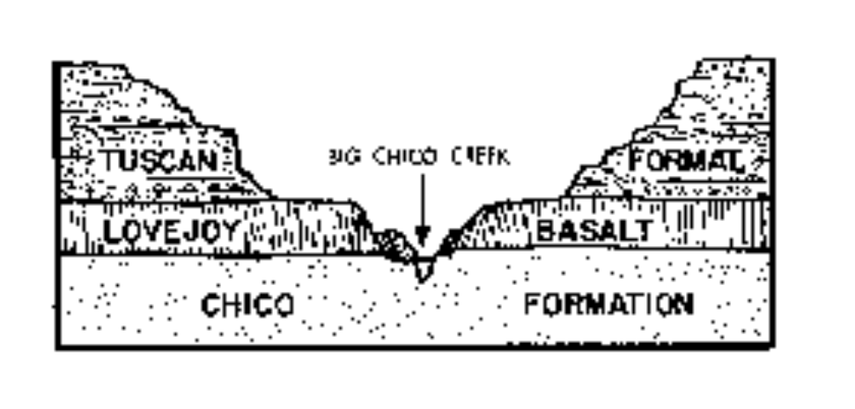
(Source of Diagram: Guyton and DeCourten, 1978, p. 9)

Reference (Optional): Introduction to the Geology of Bidwell Park, by J.W. Guyton and F.L. DeCourten: University Foundation, CSU Chico, 1978. Printed copies of this booklet are available at the Bidwell Mansion visitor center.
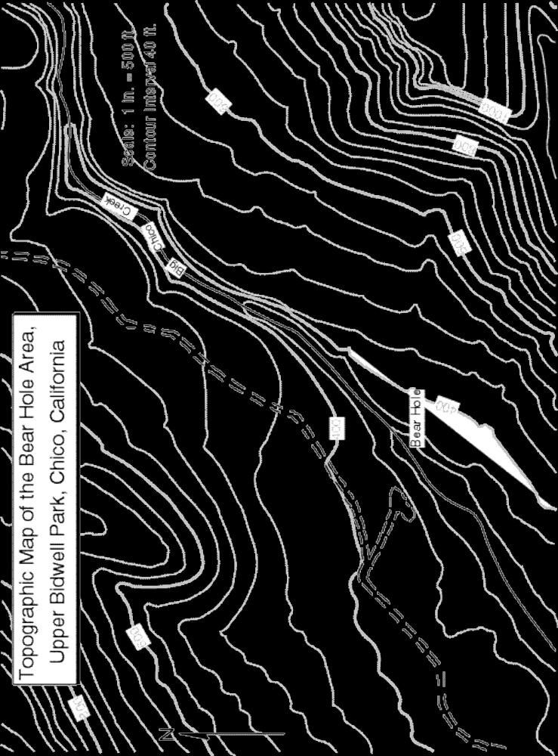

Some Comments on the Real Exam
• This exam covers convection, plate tectonics, and the rock cycle. It does NOT involve the identification of rock or mineral samples. You will do that on the first lab exam.

Practice Multiple Choice Questions
1. The three geologic environments that generate large amounts of magma are…
a. convergent plate boundaries, transform plate boundaries, and hot spots.
b. transform plate boundaries, hot spots, and divergent plate boundaries.
c. transform plate boundaries, divergent plate boundaries, and convergent plate boundaries.
d. divergent plate boundaries, convergent plate boundaries, and hot spots.
e. divergent plate boundaries, spreading ridges, and transform plate boundaries.
2. Why does magma rise toward the earth's surface?
a. The magma is denser than the surrounding rock.
b. Rock expands when it melts.
c. Magma is richer in silica than solid rock.
d. Liquids are less buoyant than solids.
e. Heat rises.
3. The driving force for plate motion is thought to be…
a. the gravitational pull of the sun, moon and planets.
b. deep ocean water currents.
c. swirling movements of the molten iron particles in the outer core.
d. the transfer of heat from deep in Earth’s interior to the surface.
e. sunspot activity.
4. Why is the Pacific plate moving toward the northwest?
a. The northwestern margin of the plate is sinking into the asthenosphere, dragging the rest of the plate with it.
b. Convection currents in the asthenosphere underneath the plate are moving toward the northwest.
c. Upwelling mantle at the East Pacific Rise (the sea-floor spreading ridge that forms the eastern margin of the Pacific plate) pushes the plate up and away from the East Pacific Rise.
d. The hot-spot under Hawaii is moving toward the northwest.
e. The North American plate is sliding past the Pacific plate toward the southeast.
5. The earth's lithosphere is comprised of…
a. the crust and the mantle.
b. the crust and the asthenosphere.
c. the crust and the uppermost part of the mantle.
d. the upper and middle portions of the mantle.
e. the ductile part of the crust and the brittle part of the mantle.
6. You can melt a hot rock by the temperature, the pressure and/or the water content.
a. increasing; increasing; increasing.
b. increasing; decreasing; increasing.
c. increasing; increasing; decreasing.
d. increasing; decreasing; decreasing.
e. decreasing; decreasing; decreasing.
7. Which of the following statements is true about the dissolved sediment in a stream?
a. It consists of tiny clay particles.
b. It makes the water cloudy.
c. It will settle to the bottom if the water becomes calm.
d. It will deposit if the water evaporates.
e. It always makes the water unsafe for drinking.
8. Loose sand transforms into hard sandstone as a result of…
a. heat and pressure.
b. compaction and cementation.
c. being wet for a long time.
d. growth of the crystals that make up the sand.
e. alignment of the sand grains due to pressure.
9. A conglomerate made of similar-sized gravel particles indicates that…
a. the water was stagnant when the gravel was deposited.
b. the water velocity was variable when the gravel was deposited.
c. the gravel was carried by a mud flow.
d. the water was flowing quickly enough to transport sand but not gravel.
e. the water was flowing too quickly to transport gravel.
10. Which of the following statements is FALSE?
a. Igneous rocks can directly become metamorphic rocks.
b. Metamorphic rocks can directly become sediment.
c. Metamorphic rocks can directly become magma.
d. Magma can directly become sedimentary rock.
e. Sedimentary rocks can directly become sediment.
11. When shale is metamorphosed into schist, which of the following will NOT occur?
a. The mineral grains in the schist become larger than the mineral grains in the shale.
b. The grains grow together, reducing pore spaces between the grains.
c. The clay minerals change into micas.
d. The minerals in the schist are all aligned in one direction.
e. The rock becomes richer in silica.
12. Foliation forms in metamorphic rocks as a result of…
a. high pressures and temperatures.
b. a higher pressure in one direction than in other directions.
c. growth of mineral grains.
d. reactions between the original minerals in the rock to form new, more stable, minerals.
e. hot chemically active fluids circulating through the rock.
Essay Questions
1. The “plates” of plate tectonics are pieces of the thin brittle outer “skin” of the Earth. What parts of the crust, mantle and core are included in this “skin?”

2. Why must a planet with divergent plate boundaries also have convergent plate boundaries?

3. How does the temperature of a substance affect its volume, density and buoyancy?

4. What is the energy source and driving mechanism for the movement of plates? Describe how this process works.

5. Two identical containers of water are heated, one from above and one from below. Which will heat more evenly (i.e. in which container will the temperature rise most uniformly)? Why?

6. Most magma is generated by melting of the mantle or the lower crust. But most of this magma doesn't stay at depth where it formed; it rises toward the Earth's surface. Why?

7. Hot asthenosphere rises to fill in the crack in the lithosphere caused by sea-floor spreading. As it does so, it partially melts. Why does it melt?

8. Which forms the largest crystals, rapid cooling of a melt or slow cooling of a melt? Why?

9. Why is magma generated at subduction zones?

10. Why do magma bodies rise up through the crust?

11. Describe how the sun makes it possible for sand to be transported from its source in the Sierra Nevada to it's final resting place in the Pacific Ocean.
Hint: The answer to this question involves two of the themes for this class: energy transfer and cycles (specifically, the rock cycle and the hydrologic cycle).

12. Subduction of oceanic lithosphere causes melting of the mantle above the subducting plate, producing mafic (i.e. basaltic) magma. The melt migrates upward and comes out of a volcano; the lava cools to form andesite (a volcanic rock with a composition intermediate between mafic and felsic). Explain how this lava could cool to form andesite, not basalt.

13. The videotape “Rocks that Form on the Earth's Surface” showed sediment settling to the bottom (being deposited) in several places where running water meets calm water. Why is that sediment being deposited?

14. Right after a storm, water is flowing very swiftly in a mountain stream. Miles downstream, the water slows down as the stream enters a large flat valley. Is any sediment deposited? If so, why?

15. Describe one cause of layering in sedimentary rocks.

16. How does sand turn into sandstone?

17. What is the fundamental difference between chemical and detrital sediment?

18. What changes take place in the minerals in a rock as the rock goes through chemical weathering?

19. Describe how foliation forms in metamorphic rocks.

20. There are three basic processes by which crystals can form. One of these processes, which occurs during metamorphism, is the recrystallization of pre-existing crystals. We saw a movie about this process (remember the steel wafer?) but, for logistical reasons, we didn't actually make crystals in class by this process. We did, however, make crystals using the other two basic processes.
Describe the two processes that we used to make crystals in class. Which is an igneous process? Which is a sedimentary process? For each process, give an example of a specific rock type whose crystals formed by that process.

21. Does water have to evaporate for limestone to form. If so, why? If not, describe how limestone can form without the evaporation of water.

Multiple Choice Questions
1. d 2. b 3. d 4. a 5. c 6. b
7. d 8. b 9. d 10. d 11. e 12. b

Essay Questions (There are always many possible good answers to essay questions. We provide here some key points that we would be looking for in good answers)
1. The “plates” of plate tectonics are pieces of the thin brittle outer “skin” of the Earth. What parts of the crust, mantle and core are included in this “skin?”

All of the crust and the uppermost part of the mantle. The uppermost part of the mantle is cool, rigid and stuck firmly to the crust above; it is not stuck firmly to the asthenosphere below.

Note: diagrams would be appropriate for this answer.

2. Why must a planet with divergent plate boundaries also have convergent plate boundaries?

New lithosphere is added wherever there is a divergent plate boundary. If we kept creating new lithosphere without destroying any, Earth would blow up like a balloon--and its overall density would have to continually decrease. We have no evidence Earth is expanding or decreasing in density so there must be just the right amount of lithosphere being destroyed at convergent plate boundaries to balance out the amount of lithosphere being created at divergent plate boundaries.

Note: diagrams would be appropriate for this answer.

3. How does the temperature of a substance affect its volume, density and buoyancy?

As the temperature of a substance increases its volume increases. Density = mass / volume. Thus, if the volume increases but the mass does not, the density must decrease. Whenever the density of a substance decreases, its buoyancy increases. Caution: when a phase change occurs (such as liquid to solid, gas to liquid), this rule may not hold true.

Note: diagrams would be appropriate for this answer.

4. What is the energy source and driving mechanism for the movement of plates? Describe how this process works.

The energy source for the movement of plates is ultimately Earth's internal energy. Earth is hotter in the center than it is on the outside. Heat always flows from hot places to cold places, so heat is constantly flowing from the center of Earth to the outside. Because the mantle (which makes up most of Earth's interior) is hotter on the bottom than it is on the top and because the mantle is capable of flowing (slowly), convection occurs in the mantle. This convection produces vertical and horizontal currents within the mantle. These currents drive plate motion but the exact way in which they do so is not understood at this time.

Note: diagrams would be appropriate for this answer.

5. Two identical containers of water are heated, one from above and one from below. Which will heat more evenly (i.e. in which container will the temperature rise most uniformly)? Why?
The container of water that is heated from below will heat very evenly. The container of water heated from above will heat very unevenly. This is because convection will occur in the container heated from below but not in the container heated from above.
The container heated from below: water near the bottom of the container will absorb heat from the heat source by conduction or radiation, increase its temperature, expand, decrease it density, increase its buoyancy and rise. As it does so, cooler denser less buoyant water sinks down to take its place; this water becomes heated and also rises. This process sets up currents that “stir” the water and distribute the heat evenly.
The container heated from above: water near the top of the container will absorb heat from the heat source by conduction or radiation, increase its temperature, expand, decrease its density, and increase its buoyancy. It will, therefore, “float” on the water below and not be able to sink down and mix with it. Thus it will stay near the heat source and its temperature will keep increasing. VERY gradually, the heat stored in the water near the top of the container will transfer, by conduction, to the water near the bottom of the container. This process is very slow because water does not conduct heat very well (this process would happen rapidly in a piece of iron or steel).
Note: diagrams would be appropriate for this answer.

6. Most magma is generated by melting of the mantle or the lower crust. But most of this magma doesn't stay at depth where it formed; it rises toward the Earth's surface. Why?
When rock melts, it expands, taking up more volume in the liquid state than it did in the solid state. Since the mass of the rock doesn't change, its density must then decrease. It is therefore more buoyant than the solid rock around it so it rises.

7. Hot asthenosphere rises to fill in the crack in the lithosphere caused by sea-floor spreading. As it does so, it partially melts. Why does it melt?
The asthenosphere partially melts in this case because it is already quite hot and because it is rising. As it rises, the pressure (from the overlying rock) decreases, making it easier for the rock to expand and, therefore, lowering its melting temperature. Thus the melting temperature can lower to a temperature below the temperature of the rock. Whenever a substance is at a temperature above its melting temperature, it melts.
Note: diagrams would be appropriate for this answer.

8. Which forms the largest crystals, rapid cooling of a melt or slow cooling of a melt? Why?

Large crystals can only grow when magma cools slowly, giving the atoms in the melt (where they can move freely) plenty of time to move to a growing crystal and attach themselves to it. When magma (or lava) cools quickly, the atoms don't have time to migrate to the first-formed crystals; instead, they rapidly join together with atoms that are already nearby, forming lots of tiny crystals.

9. Why is magma generated at subduction zones?

Sea water is constantly flowing through the oceanic crust at the bottom of the ocean. This water reacts chemically with the oceanic crust, incorporating itself into some of the crystals that form the rocks of the oceanic crust. As the oceanic lithosphere subducts, it is subjected to higher and higher pressures. The crystals that contain water become unstable under these new conditions and they recrystallize, releasing their water. This water is, of course, less dense than the rocks around it so it rises up through the mantle rock that is above the subducting oceanic lithosphere. This water then incorporates itself into crystals in that already hot mantle rock. The addition of water to the hot mantle rock lowers its melting temperature. Eventually, the melting temperature of the rock becomes less than the temperature of the rock and the rock melts (partially). The magma produced by this melting is less dense than the rocks around it so it rises. As it does so, it eventually reaches the crust. The magma transfers some of its heat to the crust around it, raising the temperature of the crust and melting it to form more magma (of a slightly different type). All of this magma continues rising through the crust, eventually cooling to form igneous rocks either underground or at the surface.

Note: diagrams would be essential for this answer.

10. Why do magma bodies rise up through the crust?

When rock melts, it expands, taking up more volume in the liquid state than it did in the solid state. Since the mass of the rock doesn't change, its density must then decrease. It is therefore more buoyant than the solid rock around it so it rises.

11. Describe how the sun makes it possible for sand to be transported from its source in the Sierra Nevada to it's final resting place in the Pacific Ocean.
Hint: the answer to this question involves two of the themes for this class: energy transfer and cycles (specifically, the rock cycle and the hydrologic cycle).

The sun provides the energy that causes water to evaporate from the ground, lakes, rivers, plants and, especially, the ocean. This energy then is stored in the water vapor as potential energy. This water eventually forms clouds and precipitation that falls on the Sierra Nevada--the energy is transformed into kinetic energy (energy of motion). Once the rain or snow lands on the ground (and the snow melts), the water runs downhill (because of gravity), carrying sediment with it and continuing to transform potential energy into kinetic energy. Eventually, the water and sediment make their way to a creek and then to a river and, finally, to the ocean.

12. Subduction of oceanic lithosphere causes melting of the mantle above the subducting plate, producing mafic (i.e. basaltic) magma. The melt migrates upward and comes out of a volcano; the lava cools to form andesite (a volcanic rock with a composition intermediate between mafic and felsic). Explain how this lava could cool to form andesite, not basalt.

As mafic magma slowly rises through the overriding plate, it cools and begins to crystallize. The crystals are denser than the melt, so they sink to the bottom of the magma chamber and get left behind as the magma continues to rise. These first-formed crystals are more mafic (poorer in silica) than the rest of the melt because it is the mafic minerals that have the highest crystallization temperature. So, because the more mafic components of the melt are removed, the melt becomes more felsic. By the time it erupts from a volcano, this melt is no longer mafic; it has become intermediate.

13. The videotape “Rocks that Form on the Earth's Surface” showed sediment settling to the bottom (being deposited) in several places where running water meets calm water. Why is that sediment being deposited?

Wherever a river empties into the ocean or a stream empties into a lake, running water meets calm water and slows down, eventually coming to an almost complete stop. In order for sediment to remain suspended in water, the water has to keep moving. The faster it moves, the heavier (usually larger) are the particles that it can carry. So when water slows down, it can no longer carry the larger particles that it was carrying, so those larger particles are deposited.
14. Right after a storm, water is flowing very swiftly in a mountain stream. Miles downstream, the water slows down as the stream enters a large flat valley. Is any sediment deposited? If so, why?
Yes, there is sediment deposited because the water slows down (see answer to question #3 above)

15. Describe one cause of layering in sedimentary rocks.
One possible answer: At any given spot on a river, the speed of the water is different at different times. Thus the size of sediment that the water is carrying--and the size of the sediment that the water is depositing--varies over time. Since each different types of sediment that is deposited forms a layer and because the different types of sediment are deposited on top of each other, you eventually get layers and layers of sediment.
Another possible answer: Storms are sometimes localized. So if a storm happens in a place where there is lots of dark rock cropping out, the sediment eroded from that place will be dark. That sediment is transported by streams to a major river and eventually deposited in the ocean. The next storm may happen in a place where there is lots of light-colored rock cropping out, resulting in the deposition of a layer of light-colored sediment.

16. How does sand turn into sandstone?
Sand is compacted under the weight of all the rock above it.
The sand grains are cemented together by calcium carbonate (calcite), silica (quartz) or iron oxides. These materials were once dissolved in the water that flowed through those pore spaces between the sand grains. But as the water flows through the sand, its chemistry or temperature may change, causing it to become saturated in calcium carbonate, silica or iron oxide. When this happens, the water can no longer hold as much of these chemicals as it had been. As a result, some of the chemical precipitates out of the water solution, growing as crystals between the sand grains. When enough of these crystals grow, the sand grains become cemented together.

17. What is the fundamental difference between chemical and detrital sediment?
Chemical sediment was once dissolved in water. Detrital sediment was not.

18. What changes take place in the minerals in a rock as the rock goes through chemical weathering?
Hydrolysis: feldspar, mica, amphibole and other minerals react chemically with acidic water to form clay and ions dissolved in water. This process turns solid crystals into powdery clay, causing the rock to disintegrate.
Oxidation: minerals that contain iron become oxidized as the iron in them combines with oxygen in the air or oxygen dissolved in water, forming iron oxides. This process turns solid crystals into powdery rust, causing the rock to disintegrate.

19. Describe how foliation forms in metamorphic rocks.
Forces deep within Earth squeeze the rock harder in one direction than in other directions, causing the micas, amphiboles and other minerals to line up parallel to one another and perpendicular to the squeezing force.
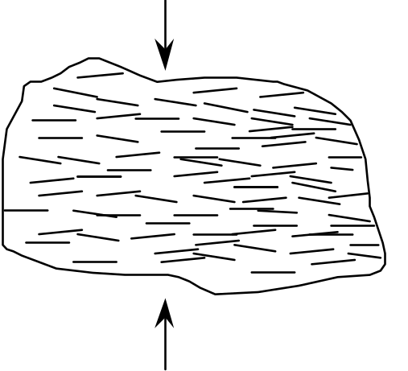

20. There are three basic processes by which crystals can form. One of these processes, which occurs during metamorphism, is the recrystallization of pre-existing crystals. We saw a movie about this process (remember the steel wafer?) but, for logistical reasons, we didn't actually make crystals in class by this process. We did, however, make crystals using the other two basic processes.
Describe the two processes that we used to make crystals in class. Which is an igneous process? Which is a sedimentary process? For each process, give an example of a specific rock type whose crystals formed by that process.
Process #1: we cooled melted salol until it crystallized. This is an igneous process because the liquid that we started out with was liquid because it was above its melting temperature. Crystallization happened when the liquid cooled to a temperature below its melting temperature. Granite is an example of a rock that forms by this process.
Process #2: we let the water evaporate out of a solution of alum in water--the alum crystallized. This is a sedimentary process because the crystals formed only when the water evaporated. The liquid that we started out with was NOT above the melting temperature of alum. Rather, the alum was dissolved in water. Most of the liquid was actually water, not alum. Rock salt is an example of a rock that forms by this process.

21. Does water have to evaporate for limestone to form. If so, why? If not, describe how limestone can form without the evaporation of water.
You can form limestone by evaporating hard water, but evaporation is not necessary for the formation of limestone. In fact, very little limestone is formed as a result of evaporation. Almost all limestone forms when living organisms extract calcium carbonate out of the water to make their “hard parts” (e.g. skeletons or shells). When these organisms die, their hard parts settle to the bottom of the ocean, forming a layer. Eventually, these hard parts are compacted and cemented together to form the hard rock called limestone.

Some Comments on the Real Exam
• This exam focuses on rocks and minerals; all of the questions on the test will be based on specimens that you will look at and test during the exam.
• The best way to study for this exam is in the lab room, with the focks. You can get access to this room any time there is no class in there (M-Th after 1:00, all day Friday, weekends). If the room and/or building are locked, call the campus police to let you in. All of your names are posted on a blanket room-access memo posted inside the display case right outside the lab room; show this list to the police officer.
• For the sake of your class mates, please keep the rock trays neat and in order. And please don't mangle the rocks or stack them on top of each other.

Tray #1
1. (white, gray, black and pink speckles)
a. Identify the glassy gray mineral in this rock.
b. Identify the pink mineral in this rock.
c. Identify the black mineral in this rock.
d. Identify this rock.
e. Did this rock form on the earth's surface or underground or both? If both, elaborate.

2. (mottled pink, with smooth top and bottom)
a. Is this one crystal or many crystals stuck together?
b. Describe the cleavage, if any, of this mineral (# of directions, angle between directions).

c. What is the hardness of this mineral?
d. Identify this mineral.
e. Name one rock that would be likely to contain this mineral.

3. (white to gray, sparkley, with red-brown streaks across it)
a. Is this one crystal or many crystals stuck together?
b. Identify the sparkley gray mineral in this rock.
c. Identify this rock.
d. This rock is…(circle all correct responses)
metamorphic volcanic plutonic porphyritic
4. (This rock was removed from the practice test.)
5. (pink, about an inch across)
a. Describe the cleavage, if any, of this mineral (# of directions, angle between directions).

b. What is the hardness of this mineral?
c. Identify this mineral.

6. (clear, box-shaped)
a. Describe the cleavage, if any, of this mineral (# of directions, angle between directions)

b. What is the hardness of this mineral?
c. Identify this mineral.

7. (two rocks in one box; both pink; one labeled “a”, the other labeled “b”)
a. Name one mineral that is present in both rocks.
b. Is rock “a” sedimentary, igneous, or metamorphic?
c. Is rock “b” sedimentary, igneous, or metamorphic?
d. One of the rocks is derived from the other. Which rock is the parent rock?
e. What happened to the one rock to transform it into the other?

8. (beige with widely-scattered dark specks, broken into two pieces)
a. This rock contains the same minerals as rock #1. Why does it look so different?

b. Name this rock.
c. This rock is…(circle all correct responses)
metamorphic volcanic plutonic porphyritic

9. (white; looks cracked; with smooth top and bottom)
a. Is this one crystal or many crystals stuck together?
b. Describe the cleavage, if any, of this mineral (# of directions, angle between directions).

c. What is the hardness of this mineral?
d. Identify this mineral.
e. Name two rocks that would be likely to contain this mineral.
Tray #2
10. (orange-red, gray, green; irregular shaped rock)
a. Is this sedimentary rock detrital or chemical?
b. Identify this rock.

11. (cherry coke red mineral embedded in gray rock)
a. What is the hardness of this mineral?
b. Identify this mineral.
c. What kind of rock is it embedded in?

12. (small, brick red, bumpy surface)
a. Name this mineral.
b. Describe one diagnostic physical property of this mineral.
c. Describe one process by which this mineral forms.

13. (speckled rock in colors of dark pink, black, light gray)
a. Identify the pink mineral in this rock.
b. Identify the black mineral in this rock.
c. Is this rock igneous, sedimentary or metamorphic?
d. Describe how this rock formed.

e. Identify this rock.

14. (two sedimentary rocks in one box; both beige with speckles of other colors)
a. These sedimentary rocks are chemical detrital (circle the correct answer).
b. Identify one mineral present in both rocks
c. Identify rock “a“: Identify rock “b”
d. The sediments that make up these rocks were deposited in running water. Was the water running faster for rock “a” or rock “b?” Explain the reasoning behind your answer.

15. (large angular flat rock; dark brick red with bright white spots)
a. Identify the black mineral in this rock.
b. This rock is…(circle all correct responses)
sedimentary detrital volcanic plutonic porphyritic
c. Describe how this rock formed.

16. (long flat dark green rock)
a. Identify the green mineral in this metamorphic rock.
b. Identify this rock.
c. Was this rock under any stress? Explain.

17. (mottled green; smooth surface)
a. What is the hardness of this mineral?
b. Identify this mineral.
c. How does this mineral form?

d. What happens to this mineral when it gets subducted?

e. What affect does this have on nearby rocks?

Tray #3
19. (large cream-colored rock )--this is an igneous rock.
a. Is this rock porphyritic or plutonic? (choose one)
b. Identify the clear glassy mineral in this rock.
c. Identify this rock.
d. Is the silica content of this rock high or low?
e. Did the magma that made this rock come out of a volcano or did it stay underground? Explain.

20. (two light-pink minerals, one labeled “a” and the other labeled “b”)
a. Describe the cleavage of mineral a.
b. Describe the cleavage of mineral b.
c. Describe the hardness of mineral a.
d. Describe the hardness of mineral b.
e. Identify mineral a.
f. Identify mineral b.
g. Name a rock in which you would expect to find these minerals.

21. (clear glassy mineral with cloudy white spot on one side)
a. What is the hardness of this mineral?
b. Describe the cleavage of this mineral.
c. Identify this mineral.
d. Name a rock in which you would expect to find this mineral.

22. (clear glassy box-shaped mineral )
a. What is the hardness of this mineral?
b. Describe the cleavage of this mineral.
c. Identify this mineral.
d. How would you distinguish this mineral from mineral #21?

23. (two yellow-brown cubes)
a. Describe the streak of this mineral.
b. What is the hardness of this mineral?
c. Identify this mineral.
d. How does this mineral form?
e. Does this mineral form deep underground or near the earth's surface? Explain.

24. (red, with sharp edges)
a. Is this rock detrital, chemical, plutonic, or volcanic? (choose one)
b. Identify this rock.
c. What is holding the different grains together?
d. Describe the characteristics you used to identify this rock.

e. Describe an environment where this type of rock could be forming today.

25. (grayish pink with long black things in it)
a. Is this rock detrital, porphyritic, plutonic, or metamorphic? (choose one)
b. Identify the black mineral.
c. Identify this rock.
d. Did this rock form on the earth's surface or underground or both (if both; elaborate)?

e. Describe an environment where this type of rock could be forming today.

26. (beige rock that looks like a granola bar)
a. This rock is (choose one)
detrital sedimentary chemical sedimentary porphyritic volcanic
plutonic igneous foliated metamorphic
b. Name one mineral in this rock
c. Name this rock
d. Describe how this rock formed.
Tray #4
27. (small; medium gray rock)
a. Is this rock detrital, chemical, volcanic or metamorphic? (choose one)
b. Identify this rock.
c. The minerals in this rock are too small to identify. But, you should still be able to name two minerals that should be in this rock. What are they?

28. (black, very shiny rock)
a. Is this rock igneous, sedimentary or metamorphic?
b. This rock is crystalline igneous volcanic plutonic glassy (circle all that apply).
c. Identify this rock.
d. How did this rock form?

29. (black; very shiny; flat and thin)
a. Describe the cleavage of this mineral.
b. Identify this mineral.
c. Find a rock in the tray that contains this mineral.

30. (gray, squarish, with brick-red coating on one side)
a. Describe the streak of this mineral.
b. Identify this mineral.
c. How does this mineral form?

31. (silver, very shiny, flat)
a. What is the hardness of this mineral?
b. Describe the cleavage of this mineral.
c. Identify this mineral.

32. (black; shaped like an arrow)
a. Is this rock sedimentary, igneous or metamorphic?
b. Identify one mineral in this rock.
c. Identify this rock.
d. Which rock would be the most likely parent rock, #27 or #35?
33. (Mason jar with water and sediment in it. Please keep upright; please do not open.)
a. Shake the jar vigorously with an up-and-down motion. Stop shaking and place the jar on the table. Three distinct layers of sediment have formed; why?

b. What size sediment forms the bottom layer? gravel sand mud
c. What was the speed of the water when the bottom layer of sediment was deposited?
fast slow no perceptible motion
d. If this bottom layer of sediment were transformed into hard rock, what would it be called?

e. What size sediment forms the middle layer? gravel sand mud
f. What was the speed of the water when the middle layer of sediment was deposited?
fast slow no perceptible motion
g. If this middle layer of sediment were transformed into hard rock, what would it be called?

h. What size sediment forms the top layer? gravel sand mud
i. What was the speed of the water when the top layer of sediment was deposited?
fast slow no perceptible motion
j. If this top layer of sediment were transformed into hard rock, what would it be called?

34. (black rock with lots of holes in it)
a. Is this rock sedimentary, igneous or metamorphic?
b. Name this rock.
c. Why does this rock have so many holes?

d. Describe how this rock formed.

e. Name the reddish brown mineral that coats some of the outside surfaces of this rock.

35. (large, black rock, with rare white streaks)
a. Is this sedimentary rock chemical or detrital?
b. What are the round spots in the rock?
c. Identify this rock.
Tray #5
36. (dirty white, mildly sparkley)
a. What is the hardness of this rock?
b. Identify the mineral that makes up this rock.
c. Identify this rock.
d. Describe how this rock formed.

e. Is this rock igneous, sedimentary or metamorphic?

37. (white, sugary, with a few orange spots)
a. What is the hardness of this rock?
b. What is the main mineral that makes up this rock?
c. Is this rock igneous, sedimentary or metamorphic?
d. Describe how this rock formed.

e. Identify this rock.

38. (dirty white, sparkley, with gray stuff on one side-a different rock)
a. What is the hardness of this rock?
b. Identify the mineral that makes up this rock.
c. Identify this rock.
d. Describe how this rock formed.

e. Is this rock igneous, sedimentary or metamorphic?

39. (dirty white, sharp edges)
a. What is the hardness of this rock?
b. Identify the mineral that makes up this rock.
c. Identify this rock.
d. Is this rock igneous, sedimentary or metamorphic?
e. This rock was derived from one of the other rocks in the tray. Which one?
f. Describe how the transformation took place.

40. (a sealed test tube with salol crystals in it)
a. Describe how the salol crystals formed.

b. Is this process an igneous process or a sedimentary process? Explain.

c. Find a rock in this tray that formed by the same process.

41. (a glass slide with alum crystals on it)
a. Describe how the crystals of alum formed.

b. Is this process an igneous process or a sedimentary process? Explain.

c. Find a rock in this tray that formed by the same process.

42. (small cream and light-gray rock)
a. Name the cream-colored mineral in this rock.
b. Name the light gray mineral in this rock.
c. How would you distinguish this rock from rock #36?

d. How would you distinguish this rock from rock #38?

43. (gray, lightweight, with lots of holes)
a. Is this rock volcanic or plutonic?
b. Name this rock.
c. Are there any crystals in this rock?
d. Describe how this rock formed.

44. (black-and-white speckled rock)
a. Identify the clear mineral in this rock.
b. Identify the white mineral in this rock.
c. Identify this rock.
Tray #6
45. (large, dark gray; one side dull; the others sparkley)
a. What are the small brownish things sticking out of the dull side of the rock?

b. Is this rock igneous, sedimentary or metamorphic?
c. Identify this rock.
d. Name one mineral in this rock.
e. How did this rock form?

46. (brown rock with sparkley things in it)
a. Identify the “sparkley” mineral.
b. Is this rock igneous, sedimentary or metamorphic?
c. Identify this rock.

47. (black rock; has the number “47” written on it)
a. Identify this rock.
b. This rock is…(circle all correct responses)
mafic felsic volcanic plutonic porphyritic
c. Describe how this rock formed.

48. (black, with a few holes)
a. Is this rock sedimentary, igneous, or metamorphic?
b. How did the holes form?
c. Identify this rock.
d. Is this rock high or low in silica?
e. How is this rock related to rock #47?

49. (small, gray, shiny)
a. What is the hardness of this mineral?
b. Describe the cleavage, if any, of this mineral (# of directions, angle between directions).
c. Identify this mineral.
50. (small, dark gray, with one flat side)
a. What is the hardness of this mineral?
b. Does this mineral have cleavage?
c. Identify this mineral.
d. How would you distinguish this mineral from #49?

51. (small, black, with gray-pink substance on one end)
a. What is the hardness of this mineral?
b. Describe the cleavage of this mineral (# of directions, angle between them).

c. Identify this mineral.
d. How would you distinguish this mineral from #50?

52. (two flat rocks in one box; one small, one very large)
a. Identify the small rock.
b. Identify the large rock.
c. Name two minerals in the small rock.
d. The large rock once looked like the small rock. Describe what changed.

e. What caused a rock similar to the small rock to change into the large rock?

53. (very small, reddish)
a. What is the hardness of this mineral?
b. Identify this mineral.
c. Name one kind of rock that might contain this mineral.

Tray #1
1. (white, gray, black and pink speckles)
a. Identify the glassy gray mineral in this rock. quartz
b. Identify the pink mineral in this rock. feldspar
c. Identify the black mineral in this rock. most are amphibole; there may be some mica
d. Identify this rock. granite
e. Did this rock form on the earth's surface or underground or both? If both, elaborate.
underground

2. (mottled pink, with smooth top and bottom)
a. Is this one crystal or many crystals stuck together? one crystal
b. Describe the cleavage, if any, of this mineral (# of directions, angle between directions).
two directions at 90° to each other
c. What is the hardness of this mineral? > 5.5
d. Identify this mineral. feldspar
e. Name one rock that would be likely to contain this mineral. any igneous rock (except obsidian or pumice, which have no minerals at all)

3. (white to gray, sparkley, with red-brown streaks across it)
a. Is this one crystal or many crystals stuck together? many crystals stuck together
b. Identify the sparkley gray mineral in this rock. calcite
c. Identify this rock. marble
d. This rock is…(circle all correct responses)
metamorphic volcanic plutonic porphyritic

5. (pink, about an inch across)
a. Describe the cleavage, if any, of this mineral (# of directions, angle between directions).
none
b. What is the hardness of this mineral? > 5.5
c. Identify this mineral. quartz
6. (clear, box-shaped)
a. Describe the cleavage, if any, of this mineral (# of directions, angle between directions).
three directions at 90° to each other
b. What is the hardness of this mineral? <3
c. Identify this mineral. halite
7. (two rocks in one box; both pink; one labeled “a”, the other labeled “b”)
a. Name one mineral that is present in both rocks. quartz
b. Is rock “a” sedimentary, igneous, or metamorphic? metamorphic
c. Is rock “b” sedimentary, igneous, or metamorphic? sedimentary
d. One of the rocks is derived from the other. Which rock is the parent rock? b (sandstone)
e. What happened to the one rock to transform it into the other? A rock like rock b (a
sandstone) was buried deep underground and heated; but it did not melt. The quartz
grains grew together into an interlocking pattern, forming rock a.
8. (beige with widely-scattered dark specks, broken into two pieces)
a. This rock contains the same minerals as rock #1. Why does it look so different?
This rock cooled from quickly at the surface. Rock #1 crystallized slowly at depth
b. Name this rock. porphyritic rhyolite
c. This rock is… (circle all correct responses)
metamorphic volcanic plutonic porphyritic
9. (white; looks cracked; with smooth top and bottom)
a. Is this one crystal or many crystals stuck together? one crystal
b. Describe the cleavage, if any, of this mineral (# of directions, angle between directions).
three directions, not at 90° to each other
c. What is the hardness of this mineral? 3
d. Identify this mineral. calcite
e. Name two rocks that would be likely to contain this mineral. limestone, marble, sandstone (as cement)
Tray #2
10. (orange-red, gray, green; irregular shaped rock)
a. Is this sedimentary rock detrital or chemical? detrital
b. Identify this rock. conglomerate

11. (cherry coke red mineral embedded in gray rock)
a. What is the hardness of this mineral? >5.5
b. Identify this mineral. garnet
c. What kind of rock is it embedded in? schist

12. (small, brick red, bumpy surface)
a. Name this mineral. iron oxide
b. Describe one diagnostic physical property of this mineral. red streak on tile
c. Describe one process by which this mineral forms. Iron-rich minerals oxidized
(combined with oxygen) to form iron oxide.

13. (speckled rock in colors of dark pink, black, light gray)
a. Identify the pink mineral in this rock. feldspar
b. Identify the black mineral in this rock. mica or amphibole
c. Is this rock igneous, sedimentary or metamorphic? igneous
d. Describe how this rock formed. felsic magma cooled deep under ground
e. Identify this rock. granite

14. (two sedimentary rocks in one box; both beige with speckles of other colors)
a. These sedimentary rocks are chemical detrital (circle the correct answer).
b. Identify one mineral present in both rocks. quartz
c. Identify rock “a.” sandstone Identify rock “b.” conglomerate
d. The sediments that make up these rocks were deposited in running water. Was the water running faster for rock “a” or rock “b?” Explain the reasoning behind your answer.
The water was running faster for rock "b". The faster water flows, the greater the size
of the sediment particles it can carry. Since the conglomerate is made of larger
sediment particles, the water must have been flowing faster when it was deposited.
15. (large angular flat rock; dark brick red with bright white spots)
a. Identify the black mineral in this rock. amphibole
b. This rock is…(circle all correct responses)
sedimentary detrital volcanic plutonic porphyritic
c. Describe how this rock formed. This rock was originally magma under the ground.
The black and white crystals formed while the magma was still underground. The
magma was then ejected as a mixture of molten lava and crystals through a volcano.
The red "ground mass" then quickly crystallized at the surface, forming crystals that
are too small to distinguish with the naked eye.

16. (long flat dark green rock)
a. Identify the green mineral in this metamorphic rock. chlorite
b. Identify this rock. schist
c. Was this rock under any stress? Explain. Yes; this rock was pressed and flattened,
forming foliation.

17. (mottled green; smooth surface)
a. What is the hardness of this mineral? around 2.5
b. Identify this mineral. serpentine
c. How does this mineral form? water circulates through oceanic crust, turning some of the minerals into serpentine
d. What happens to this mineral when it gets subducted? it loses water

e. What affect does this have on nearby rocks? It can cause them to melt (adding water
to a rock lowers its melting temperature).

Tray #3
19. (large cream-colored rock—this is an igneous rock)
a. Is this rock porphyritic or plutonic? (choose one) porphyritic
b. Identify the clear glassy mineral in this rock. quartz
c. Identify this rock. rhyolite
d. Is the silica content of this rock high or low? high
e. Did the magma that made this rock come out of a volcano or did it stay underground? Explain. The magma that formed this rock stayed under the ground long enough to
form nice quartz crystals. The mixture of magma and quartz crystals erupted onto
the surface. The melt cooled quickly, forming the white matrix of microscopic crystals.

20. (two light-pink minerals, one labeled “a” and the other labeled “b”)
a. Describe the cleavage of mineral a. two directions at 90°
b. Describe the cleavage of mineral b. two directions at 90°
c. Describe the hardness of mineral a. > 5.5
d. Describe the hardness of mineral b. > 5.5
e. Identify mineral a. feldspar
f. Identify mineral b. feldspar
g. Name a rock in which you would expect to find these minerals. any igneous rock

21. (clear glassy mineral with cloudy white spot on one side)
a. What is the hardness of this mineral? > 5.5
b. Describe the cleavage of this mineral. none
c. Identify this mineral. quartz
d. Name a rock in which you would expect to find this mineral. sandstone, granite,
quartzite, and many more

22. (clear glassy box-shaped mineral )
a. What is the hardness of this mineral? 3
b. Describe the cleavage of this mineral. three directions, not at 90°
c. Identify this mineral. calcite
d. How would you distinguish this mineral from mineral #21? #22 has cleavage and
double refraction; it is softer than glass and fizzes when exposed to the dilute
hydrochloric acid (but please don't put acid on this specimen; it will make it cloudy)

23. (two yellow-brown cubes)
a. Describe the streak of this mineral. yellow - brown
b. What is the hardness of this mineral? between 3 and 5.5
c. Identify this mineral. iron oxide
d. How does this mineral form? iron-rich minerals oxidize (combine with oxygen)
e. Does this mineral form deep underground or near the earth's surface? Explain.
This mineral must have formed near the earth's surface because the oxidation process
requires oxygen-rich air. There is no air deep in the ground

24. (red, with sharp edges)
a. Is this rock detrital, chemical, plutonic, or volcanic? (choose one) detrital
b. Identify this rock. conglomerate
c. What's holding the different grains together? quartz cement
d. Describe the characteristics you used to identify this rock. gravel, cemented together
e. Describe an environment where this type of rock could be forming today.
in the bed of a swiftly-flowing stream (in or near mountains)

25. (grayish pink with long black things in it)
a. Is this rock detrital, porphyritic, plutonic, or metamorphic? (choose one) porphyritic
b. Identify the black mineral. amphibole
c. Identify this rock. rhyolite
d. Did this rock form on the earth's surface or underground or both (if both; elaborate)?
both; the amphibole formed underground; the rest formed on the surface
e. Describe an environment where this type of rock could be forming today.
Mt. Lassen and other volcanoes, especially near subduction zones.

26. (beige rock that looks like a granola bar)
a. This rock is (choose one)
detrital sedimentary chemical sedimentary porphyritic volcanic
plutonic igneous foliated metamorphic
b. Name one mineral in this rock. calcite
c. Name this rock. limestone
d. Describe how this rock formed. Shell fish drank water and used dissolved calcium carbonate to make their shells. After the shell fish died, their shells settled to the bottom, forming a layer. As other layers of sediment accumulated on top, the shells were compacted and cemented together to form limestone.
Tray #4
27. (small; medium gray rock)
a. Is this rock detrital, chemical, volcanic or metamorphic? (choose one) detrital
b. Identify this rock. shale (mudstone is also an acceptable answer)
c. The minerals in this rock are too small to identify. But, you should still be able to name two minerals that should be in this rock. What are they? Clay and calcite

28. (black, very shiny rock)
a. Is this rock igneous, sedimentary or metamorphic? igneous
b. This rock is crystalline igneous volcanic plutonic glassy (circle all that apply)
c. Identify this rock. obsidian
d. How did this rock form? felsic lava cooled VERY quickly

29. (black; very shiny; flat and thin)
a. Describe the cleavage of this mineral. one direction
b. Identify this mineral. mica
c. Find a rock in the tray that contains this mineral. #32

30. (gray, squarish, with brick-red coating on one side)
a. Describe the streak of this mineral. red
b. Identify this mineral. iron oxide
c. How does this mineral form? oxidation of iron-rich minerals during weathering

31. (silver, very shiny, flat)
a. What is the hardness of this mineral? < 2.5
b. Describe the cleavage of this mineral. one direction
c. Identify this mineral. mica

32. (black; shaped like an arrow)
a. Is this rock sedimentary, igneous or metamorphic? metamorphic
b. Identify one mineral in this rock. mica
c. Identify this rock. schist
d. Which rock would be the most likely parent rock, #27 or #35? #27
33. (Mason jar with water and sediment in it . Please keep upright; please do not open)
a. Shake the jar vigorously with an up-and-down motion. Stop shaking and place the jar on the table. Three distinct layers of sediment have formed; why?
The largest particles are on the bottom because they settled first. They settled first because the water needs to be moving very quickly to keep particles that large and heavy suspended. Right after the shaking stopped, the water slowed down enough to deposit the gravel but not enough to deposit the smaller and lighter sand. The sand settled next as the water continued to slow down. Finally, the tiny mud particles settled very gradually after the water had stopped moving.
b. What size sediment forms the bottom layer? gravel sand mud
c. What was the speed of the water when the bottom layer of sediment was deposited?
fast slow no perceptible motion
d. If this bottom layer of sediment were transformed into hard rock, what would it be called? conglomerate
e. What size sediment forms the middle layer? gravel sand mud
f. What was the speed of the water when the middle layer of sediment was deposited?
fast slow no perceptible motion
g. If this middle layer of sediment were transformed into hard rock, what would it be called? sandstone
h. What size sediment forms the top layer? gravel sand mud
i. What was the speed of the water when the top layer of sediment was deposited?
fast slow no perceptible motion
j. If this top layer of sediment were transformed into hard rock, what would it be called?
mudstone or shale

34. (black rock with lots of holes in it)
a. Is this rock sedimentary, igneous or metamorphic? igneous
b. Name this rock. basalt
c. Why does this rock have so many holes? Gas bubbles in the lava were frozen in place.
d. Describe how this rock formed. This rock was originally mafic magma below the earth's surface. A volcanic eruption occurred and ejected the magma as lava. It then quickly cooled.
e. Name the reddish brown mineral that coats some of the outside surfaces of this rock.
iron oxide

35. (large, black rock, with rare white streaks)
a. Is this sedimentary rock chemical or detrital? chemical (biochemical)
b. What are the round spots in the rock? fossils
c. Identify this rock. limestone
Tray #5
36. (dirty white, mildly sparkley)
a. What is the hardness of this rock? between 2.5 and 3
b. Identify the mineral that makes up this rock. halite
c. Identify this rock. rock salt
d. Describe how this rock formed. Salty water evaporated.

e. Is this rock igneous, sedimentary or metamorphic? sedimentary

37. (white, sugary, with a few orange spots)
a. What is the hardness of this rock? > 5.5
b. What is the main mineral that makes up this rock? quartz
c. Is this rock igneous, sedimentary or metamorphic? sedimentary
d. Describe how this rock formed. sand was deposited; then buried, compacted and
cemented.
e. Identify this rock. sandstone

38. (dirty white, sparkley, with gray stuff on one side-a different rock)
a. What is the hardness of this rock? 3
b. Identify the mineral that makes up this rock. calcite
c. Identify this rock. marble
d. Describe how this rock formed. limestone was subjected to high temperatures
and metamorphosed
e. Is this rock igneous, sedimentary or metamorphic? metamorphic

39. (dirty white, sharp edges)
a. What is the hardness of this rock? > 5.5
b. Identify the mineral that makes up this rock. quartz
c. Identify this rock. quartzite
d. Is this rock igneous, sedimentary or metamorphic? metamorphic
e. This rock was derived from one of the other rocks in the tray. Which one? #37
f. Describe how the transformation took place. metamorphism; at high temperatures, the quartz grains grew into each other

40. (a sealed test tube with salol crystals in it)
a. Describe how the salol crystals formed. from the slow cooling of melted salol

b. Is this process an igneous process or a sedimentary process? Explain.
igneous process, the crystals are visible thus they cooled slowly
c. Find a rock in this tray that formed by the same process. #42 or #44

41. (a glass slide with alum crystals on it)
a. Describe how the crystals of alum formed. They formed when the water evaporated, leaving the alum behind.
b. Is this process an igneous process or a sedimentary process? Explain.
This is a sedimentary process; the alum crystals chemically precipitated out of solution, just like halite.
c. Find a rock in this tray that formed by the same process. #36

42. (small cream and light-gray rock).
a. Name the cream-colored mineral in this rock. feldspar
b. Name the light gray mineral in this rock. quartz
c. How would you distinguish this rock from rock #36? it is harder and does not taste salty
d. How would you distinguish this rock from rock #38? it is harder and does not react with hydrochloric acid

43. (gray, lightweight, with lots of holes)
a. Is this rock volcanic or plutonic? volcanic
b. Name this rock pumice
c. Are there any crystals in this rock? no; it is all glass
d. Describe how this rock formed. felsic foamy lava cooled very quickly

44. (black-and-white speckled rock)
a. Identify the clear mineral in this rock. quartz
b. Identify the white mineral in this rock. feldspar
c. Identify this rock. granite

Tray #6
45. (large, dark gray; one side dull; the others sparkley)
a. What are the small brownish things sticking out of the dull side of the rock?
fossils
b. Is this rock igneous, sedimentary or metamorphic? sedimentary
c. Identify this rock. limestone
d. Name one mineral in this rock. calcite
e. How did this rock form? Shell fish extracted calcium carbonate (calcite) from the
water to make their shells; the shells settled to the bottom and then cemented together.

46. (brown rock with sparkley things in it)
a. Identify the “sparkley” mineral mica
b. Is this rock igneous, sedimentary or metamorphic? sedimentary
c. Identify this rock sandstone

47. (black rock; has the number “47” written on it)
a. Identify this rock. gabbro
b. This rock is…(circle all correct responses)
mafic felsic volcanic plutonic porphyritic
c. Describe how this rock formed. mafic magma cooled slowly under the ground

48. (black, with a few holes)
a. Is this rock sedimentary, igneous, or metamorphic? igneous
b. How did the holes form? bubbles in lava were frozen in place
c. Identify this rock. basalt
d. Is this rock high or low in silica? low in silica
e. How is this rock related to rock #47? it is the volcanic version of gabbro; both are mafic

49. (small, gray, shiny)
a. What is the hardness of this mineral? >5.5
b. Describe the cleavage, if any, of this mineral (# of directions, angle between directions). none
c. Identify this mineral. quartz
50. (small, dark gray, with one flat side)
a. What is the hardness of this mineral? > 5.5
b. Does this mineral have cleavage? yes, 2 directions at 90°
c. Identify this mineral. feldspar
d. How would you distinguish this mineral from #49? this one has cleavage

51. (small, black, with gray-pink substance on one end)
a. What is the hardness of this mineral? > 5.5
b. Describe the cleavage of this mineral (# of directions, angle between them)
2 directions, not at 90°
c. Identify this mineral. amphibole
d. How would you distinguish this mineral from #50? the cleavage angle is different

52. (two flat rocks in one box; one small, one very large)
a. Identify the small rock mudstone
b. Identify the large rock schist
c. Name two minerals in the small rock. Clay and calcite
d. The large rock once looked like the small rock. Describe what changed.
the large rock has foliation, larger grain size, new mineral grew such as garnet
e. What caused a rock similar to the small rock to change into the large rock?
mudstone metamorphosed when it was subjected to high temperature and pressure

53. (very small, reddish)
a. What is the hardness of this mineral? > 5.5
b. Identify this mineral. garnet
c. Name one kind of rock that might contain this mineral. schist

This laboratory activity was modified from a) The River Cutters unit of the Great Explorations in Math and Science (GEMS) curriculum materials for Grades 6–9, published in 1989 by the Lawrence Hall of Science, University of California at Berkeley. b) The Stream Tables activity of the Landforms Module of the Full Option Science System (FOSS) curriculum materials for grades 5–6, published in 1990 by the Lawrence Hall of Science, University of California at Berkeley; distributed by Encyclopaedia Brittanica.
A tributary is a side stream that joins the main stream (which is called the trunk stream). These terms derive from the resemblance between river systems and trees. See, for example, Figure 5.4 on p. 119 in the textbook; the tributaries are the finer “branches” of the “tree” and the trunk stream is the “trunk” of the “tree.”
In the textbook, read the text on p. 125 and study Figures 5.10 through 5.12 on p. 124–125.
In the textbook, read the text on p. 129 and study Figures 5.19 and 5.20 on p. 129–130.
Foliation is layering in the rock formed when elongate or flat crystals are all lined up the same way.
We use the term “particles” here to mean individual pieces of sediment; an individual particle may be 10 feet across!
We use the term “particles” here to mean individual pieces of sediment; an individual particle may be 10 feet across!

